** PERIYAR ARTS COLLEGE,CUDDALORE -1**

**PG & RESEARCH DEPARTMENT OF ZOOLOGY**

**AFFILIATED TO THIRUVALLUVAR UNIVERSITY**

**STUDY MATERIAL**

|  |  |  |  |
| --- | --- | --- | --- |
| **COURSE** | **II M.Sc ZOOLOGY** | **YEAR:2020-2021** | **SEMESTER- III** |
| **SUBJECT PAPER** | **Development Biology** | **Paper Code** | **MZO32** |
| **PREPARED BY NAME** | **Dr.S.P.Vinotha** |  |  |
| **DESIGNATION** | **Assistant Professor** |  |  |

**UNIT-I: EARLY DEVELOPMENT**

Gastrulation movements: role of egg cortex - cell surface in morphogenesis. Cell adhesion and cell communication. Chemotactic induced aggregation - aggregation in sponges. Experimental analyses in the early development of Echinoderms, Amphibians and birds.

**UNIIT-V: EMBRYONIC NUTRITION**

Nutritional requirements of Embryo- modes of embryonic nutrition –Food reserve and embryonic nutrition- embryonic nutrition from mother –physiology of placenta

**UNIT-I: EARLY DEVELOPMENT**

**Gastrulation Movements:**

**Role of Egg Cortex**

Distribution of visible materials in the egg and in the embryo during cleavage is, however, not always of crucial importance for the localization of parts in the developing embryo. Some substances and cellular inclusions may be displaced without disturbing the normal segregation of the embryo into its subordinate parts.This displacement can most conveniently be accomplished by centrifugation of the un-cleaved eggs. Centrifuging the eggs of most animals for a few minutes with moderate speeds, at an acceleration of several thousand times gravity, is sufficient to rearrange various cellular inclusions in the interior of the egg according to their specific gravities.After sufficiently strong centrifugation, the eggs become stratified and show at least three typical layers. At the centripetal pole there is usually an accumulation of fat or lipid droplets, which are the lightest constituents of the egg cytoplasm.

A layer of hyaline cytoplasm, which is the ground substance of the egg, follows. The nucleus or asters with chromosomes (if the centrifuged egg was in meiosis or mitosis) are also found in the hyaline layer. The yolk, as the most dense and heavy constituent of the egg, accumulates at the centrifugal pole.

In the eggs of some animals the vegetal pole is so much heavier, owing to the presence of yolk, that it becomes oriented centrifugally during centrifugation. In this case the yolk is not displaced from its normal site at the vegetal pole but is only more concentrated. To displace the yolk in these cases the eggs have to be fixed in a desired position, so that they cannot freely rotate. This can sometimes be done by sucking them into narrow capillaries or by embedding the eggs in gelatin prior to centrifugation.

If the main axis of the embryo lies at random to the centrifugal force, as often happens, cellular inclusions will be dislocated to different parts in individual eggs. The results of centrifuging eggs of the sea urchin Arbacia. The red pigment granules present in these eggs are concentrated at the centrifugal end of the egg. Some scattering of the granules occurs after the centrifuging is stopped and before cleavage progresses sufficiently to prevent further redistribution of the granules by subdividing the egg into blastomeres.

It now becomes evident that the granules are concentrated in different positions in respect to the egg axis – near the vegetal pole, near the animal pole, or toward one side. Independently of the position of the granules, the invagination of the blastopore occurs at the vegetal pole, so that the region of the blastopore will contain the pigment granules in some embryos but not in others.

It has often been found that the pattern of cleavage may be highly independent of the distribution of cytoplasmic substances inside the egg. The cleavage of the mollusc Dentalium, in which a polar lobe appears at the vegetal pole during the first and second divisions of the egg and contains the cytoplasm necessary for the development of the mesoderm in the larva.

A similar polar lobe is observed during cleavage of another mollusc, Ilyanassa. The polar lobe in this species is normally filled with yolky cytoplasm, while at the animal pole the egg cytoplasm is fairly free from yolk. Eggs of Ilyanassa have been centrifuged “in reverse,” that is, with the vegetal pole fixed in position, facing the axis of the centrifuge. As a result, the heavy yolk is thrown into the animal hemisphere (still marked by the position of the polar bodies), and the hyaline cytoplasm and lipid droplets are concentrated at the vegetal pole.

Nevertheless, the polar lobe appears at the vegetal pole when the egg starts cleaving, although the lobe now contains mainly hyaline cytoplasm and lipid instead of the yolk granules. Obviously, the formation of the polar lobe is not dependent on the yolk normally located at the vegetal pole, but on something that is not displaced by the centrifugal force.

What can this something be? There are two possibilities. The first is that in the cytoplasm some fixed network exists with sufficiently broad meshes to allow for the free movement of yolk granules and other inclusions without itself being torn or distorted. In fact a system of “skeletal” fibers has been found to exist in many kinds of cells.

There is so far no evidence, however, that the polarity of the egg is dependent on the existence of such an internal skeleton, neither is it certain that such an internal skeleton, if it existed in the eggs, would not be dislodged by centrifugation. The other alternative is that the fixed system which is not displaced by centrifugation is the cortical layer of cytoplasm, or the cortex of the egg.

This is in conformity with direct ob­servation, for the cortical granules are not displaced by centrifugation. The layer of cytoplasm in which they are embedded is therefore suf­ficiently viscous to resist the forces usually generated in centrifugation experiments.

Since the immovable cortex of the egg appears to determine the point at which invagination begins in centrifuged Arbacia eggs, as well as the position of the vegetal polar lobe in Ilyanassa, the further suggestion may be made that the cortex is the actual carrier of the polarity of the egg, or that the polarity of the egg is ingrained in its cortex.

If this were the case, the distribution of substances in the interior of the egg might be expected to be controlled or determined by the egg cortex. This suggestion finds support in some further results of centrifugation experiments, namely, the fact that cell con­stituents tend to return to their normal positions after the cessation of centrifuging.

A scattering or mixing up of the strata into which the egg contents had been arranged by centrifugation could be the result of random movement of particles. This explanation, however, does not apply to cases in which after centrifugation certain particles not only move from the position to which they were brought by the centrifugal force but take up a very definite location in the egg.

In the egg of the ascidian Styela different kinds of egg cytoplasm may be displaced by centrifugation. Immediately after centrifugation the eggs show a clear stratification. The yellow granules, which go into the formation of mesoderm, are displaced to the centripetal pole; the yolk is displaced to the centrifugal pole; and the hyaline cytoplasm remains as a layer in between.

When the eggs are left to themselves after centrifugation, the egg substances start flowing and rearranging them in the interior of the egg. If the cell divisions set in sufficiently soon, this rearrangement is stopped by partitions appearing between the cleavage cells, and the result is the formation of the abnormal embryos dealt with earlier.

If, however, the eggs are centrifuged well in advance of the beginning of cleavage, or if the first divisions of the egg are delayed, the redistribution of the egg contents may proceed so far that normal conditions are attained. The end result of such redistribution- the yolk is at the vegetal pole; the animal hemisphere is filled with hyaline cytoplasm; and the yellow granules take up a subequatorial area on one side of the egg, corresponding to the mesodermal “yellow crescent” of normal development.

Another and perhaps even more impressive example is that of the egg of the mollusc Aplasia limacina. In the eggs of this animal there are granules containing ascorbic acid (vitamin C), probably connected with the Golgi bodies. In immature oocytes the ascorbic acid granules are uniformly distributed throughout the egg cyto­plasm.

During maturation the granules accumulate in a ring lying inside the cortical cytoplasm and somewhat above the equator. By centrifugation the granules are concen­trated at the centrifugal pole, but after cessation of centrifugation the ascorbic acid granules soon start moving and again take up their normal position as a supraequatorial ring.

The most plausible explanation of the two preceding experiments is that the displaced cytoplasmic particles tend to return to the proximity of certain regions of the egg cortex which had remained in their respective positions all the time that the egg was being centrifuged.

It follows that in normal development the cytoplasmic substances in the egg are distributed in relation to local differences in the egg cortex, and that it is the egg cortex, therefore, that foreshadows, in some way, the pattern of future development of the embryo.

Local differences in the egg surface have been recorded by various authors, and in some cases the differences are very obvious if the eggs or early embryos are examined with the scanning electron microscope- in molluscs forming a polar lobe during early cleavage the cortex of the lobe has a different sculpture from the rest of the egg (embryo).

**Cell Surface in Morphogenesis**

A body is more than a collection of randomly distributed cell types. Development involves not only the differentiation of cells, but also their organization into multicellular arrangements such as tissues and organs. When we observe the detailed anatomy of a tissue such as the neural retina of the eye, we see an intricate and precise arrangement of many types of cells. How can matter organize itself so as to create a complex structure such as a limb or an eye?

There are five major questions for embryologists who study morphogenesis:

1.**How are tissues formed from populations of cells?**

For example, how do neural retina cells stick to other neural retina cells and not become integrated into the pigmented retina or iris cells next to them? How are the various cell types within the retina (the three distinct layers of photoreceptors, bipolar neurons, and ganglion cells) arranged so that the retina is functional?

2.**How are organs constructed from tissues?**

 The retina of the eye forms at a precise distance behind the cornea and the lens. The retina would be useless if it developed behind a bone or in the middle of the kidney. Moreover, neurons from the retina must enter the brain to innervate the regions of the brain cortex that analyze visual information. All these connections must be precisely ordered.

3.**How do organs form in particular locations, and how do migrating cells reach their destinations?**

Eyes develop only in the head and nowhere else. What stops an eye from forming in some other area of the body? Some cells—for instance, the precursors of our pigment cells, germ cells, and blood cells—must travel long distances to reach their final destinations. How are cells instructed to travel along certain routes in our embryonic bodies, and how are they told to stop once they have reached their appropriate destinations?

4.**How do organs and their cells grow, and how is their growth coordinated throughout development?**

The cells of all the tissues in the eye must grow in a coordinated fashion if one is to see. Some cells, including most neurons, do not divide after birth. In contrast, the intestine is constantly shedding cells, and new intestinal cells are regenerated each day. The mitotic rate of this tissue must be carefully regulated. If the intestine generated more cells than it sloughed off, it could produce tumorous outgrowths. If it produced fewer cells than it sloughed off, it would soon become nonfunctional. What controls the rate of mitosis in the intestine?

5.**How do organs achieve polarity?**

 If one were to look at a cross section of the fingers, one would see a certain organized collection of tissues—bone, cartilage, muscle, fat, dermis, epidermis, blood, and neurons. Looking at a cross section of the forearm, one would find the same collection of tissues. But they are arranged very differently in different parts of the arm. How is it that the same cell types can be arranged in different ways in different parts of the same structure?

All these questions concern aspects of cell behavior. There are two major types of cell arrangements in the embryo: **epithelial cells**, which are tightly connected to one another in sheets or tubes, and **mesenchymal cells**, which are unconnected to one another and which operate as independent units. Morphogenesis is brought about through a limited repertoire of variations in cellular processes within these two types of arrangements: (1) the direction and number of cell divisions; (2) cell shape changes; (3) cell movement; (4) cell growth; (5) cell death; and (6) changes in the composition of the cell membrane or secreted products. We will discuss the last of these considerations here.

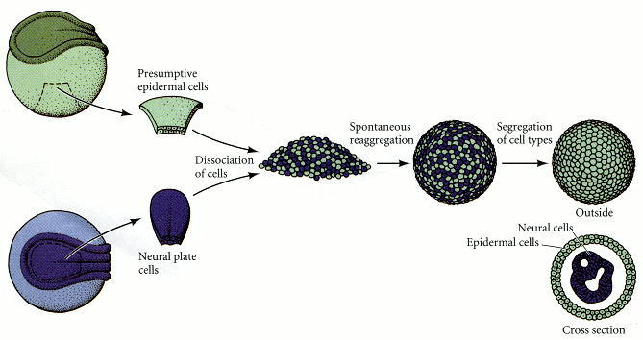 The results of their experiments were striking. First, they found that reaggregated cells become spatially segregated. That is, instead of the two cell types remaining mixed, each cell type sorts out into its own region. Thus, when epidermal (ectodermal) and mesodermal cells are brought together to form a mixed aggregate, the epidermal cells move to the periphery of the aggregate and the mesodermal cells move to the inside. In no case do the recombined cells remain randomly mixed, and in most cases, one tissue type completely envelops the other.

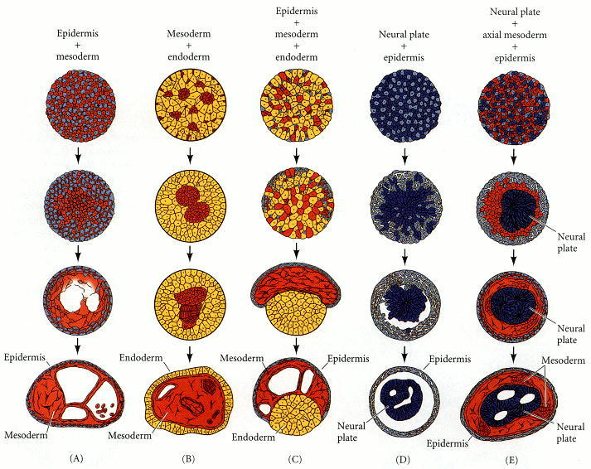

Such selective affinities were also noted by [Boucaut (1974)](https://www.ncbi.nlm.nih.gov/books/NBK10021/), who injected individual cells from specific germ layers into the body cavity of amphibian gastrulae. He found that these cells migrated back to their appropriate germ layer. Endodermal cells found positions in the host endoderm, whereas ectodermal cells were found only in host ectoderm. Thus, selective affinity appears to be important for imparting positional information to embryonic cells.

The third conclusion of Holtfreter and his colleagues was that selective affinities change during development. This should be expected, because embryonic cells do not retain a single stable relationship with other cell types. For development to occur, cells must interact differently with other cell populations at specific times. Such changes in cell affinity are extremely important in the processes of morphogenesis.

The skin cells are separated by proteolytic enzymes and then aggregated in a rotary culture. The epidermal cells of each aggregate migrate to the periphery, and the dermal cells migrate toward the center. In 72 hours, the epidermis has been reconstituted, a keratin layer has formed, and interactions between these tissues form hair follicles in the dermal region. Such reconstruction of complex tissues from individual cells is called **histotypic aggregation**

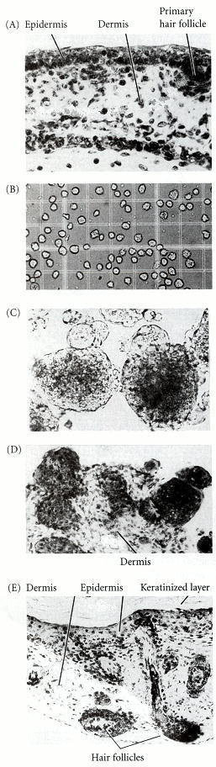

## The thermodynamic model of cell interactions

Cells, then, do not sort randomly, but can actively move to create tissue organization. What forces direct cell movement during morphogenesis? In 1964, Malcolm Steinberg proposed the **differential adhesion hypothesis**, a model that explained patterns of cell sorting based on thermodynamic principles. Using cells derived from trypsinized embryonic tissues, Steinberg showed that certain cell types always migrate centrally when combined with some cell types, but migrate peripherally when combined with others. [Figure 3.29](https://www.ncbi.nlm.nih.gov/books/NBK10021/figure/A383/?report=objectonly) illustrates the interactions between pigmented retina cells and neural retina cells. When single-cell suspensions of these two cell types are mixed together, they form aggregates of randomly arranged cells. However, after several hours, the pigmented retina cells are no longer seen on the periphery of the aggregates, and after 2 days, two distinct layers are seen, with the pigmented retina cells lying internal to the neural retina cells. Moreover, such interactions form a hierarchy ([Steinberg 1970](https://www.ncbi.nlm.nih.gov/books/NBK10021/)). If the final position of one cell type, A, is internal to a second cell type, B, and the final position of B is internal to a third cell type, C, then the final position of A will always be internal to C. For example, pigmented retina cells migrate internally to neural retina cells, and heart cells migrate internally to pigmented retina cells. Therefore, heart cells migrate internally to neural retina cells.

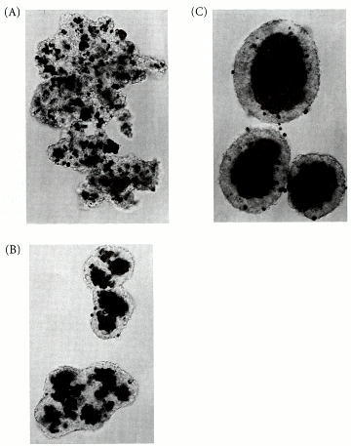

This observation led Steinberg to propose that cells interact so as to form an aggregate with the smallest interfacial free energy. In other words, the cells rearrange themselves into the most thermodynamically stable pattern. If cell types A and B have different strengths of adhesion, and if the strength of A-A connections is greater than the strength of A-B or B-B connections, sorting will occur, with the A cells becoming central. On the other hand, if the strength of A-A connections is less than or equal to the strength of A-B connections, then the aggregate will remain as a random mix of cells. Finally, if the strength of A-A connections is far greater than the strength of A-B connections—in other words, if A and B cells show essentially no adhesivity toward one another—then A cells and B cells will form separate aggregates. According to this hypothesis, the early embryo can be viewed as existing in an equilibrium state until some change in gene activity changes the cell surface molecules. The movements that result seek to restore the cells to a new equilibrium configuration.

## Cell adhesion and cell communication

## Cadherins and cell adhesion

Recent evidence shows that boundaries between tissues can indeed be created both by (1) different cell types having different types of cell adhesion molecules and (2) different cell types having different amounts of cell adhesion molecules. There are several classes of molecules that can mediate cell adhesion. The major cell adhesion molecules appear to be the **cadherins**. As their name suggests, they are *ca*lcium-dependent *adh*esion molecules.

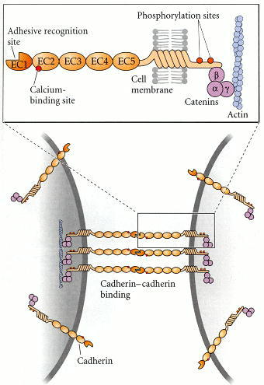

In vertebrate embryos, several major cadherin classes have been identified:

* **E-cadherin** (epithelial cadherin, also called uvomorulin and L-CAM) is expressed on all early mammalian embryonic cells, even at the 1-cell stage. Later, this molecule is restricted to epithelial tissues of embryos and adults.
* **P-cadherin** (placental cadherin) appears to be expressed primarily on the trophoblast cells (those placental cells of the mammalian embryo that contact the uterine wall) and on the uterine wall epithelium ([Nose and Takeichi 1986](https://www.ncbi.nlm.nih.gov/books/NBK10021/)). It is possible that P-cadherin facilitates the connection of the embryo to the uterus, since P-cadherin on the uterine cells is seen to contact P-cadherin on the trophoblast cells of mouse embryos ([Kadokawa et al. 1989](https://www.ncbi.nlm.nih.gov/books/NBK10021/)).
* **N-cadherin** (neural cadherin) is first seen on mesodermal cells in the gastrulating embryo as they lose their E-cadherin expression. It is also highly expressed on the cells of the developing central nervous system ([Figure 3.32](https://www.ncbi.nlm.nih.gov/books/NBK10021/figure/A390/?report=objectonly); [Hatta and Takeichi 1986](https://www.ncbi.nlm.nih.gov/books/NBK10021/)).
* **EP-cadherin** (C-cadherin) has been found to be critical for maintaining adhesion between the blastomeres of the *Xenopus* blastula and is required for the normal movements of gastrulation ([Figure 3.33](https://www.ncbi.nlm.nih.gov/books/NBK10021/figure/A392/?report=objectonly); [Heasman et al. 1994](https://www.ncbi.nlm.nih.gov/books/NBK10021/); [Lee and Gumbiner 1995](https://www.ncbi.nlm.nih.gov/books/NBK10021/)).
* **Protocadherins** are calcium-dependent adhesion proteins that differ from the classic cadherins in that they lack connections to the cytoskeleton through catenins. Protocadherins have been found to be very important in separating the notochord from the other mesodermal tissues during *Xenopus* gastrulation

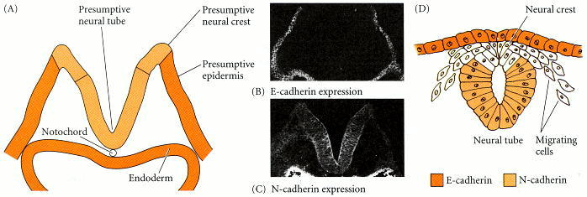

Cadherins join cells together by binding to the same type of cadherin on another cell. Thus, cells with E-cadherin stick best to other cells with E-cadherin, and they will sort out from cells containing N-cadherin in their membranes. This pattern is called **homophilic binding**.

These adhesion patterns may have important consequences in the embryo. In the gastrula of the frog *Xenopus,* the neural tube expresses N-cadherin, while the epidermis expresses E-cadherin. Normally, these two tissues separate from each other such that the neural tube is inside the body and the epidermis covers the body (see [Figure 3.32](https://www.ncbi.nlm.nih.gov/books/NBK10021/figure/A390/?report=objectonly)). If the epidermis is experimentally manipulated to remove its E-cadherin, the epidermal epithelium cannot hold together. If the epidermis is made to express N-cadherin, or if the neural cells are made to lose it, the neural tube will not separate from the epidermis

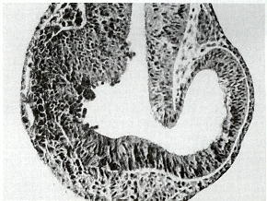

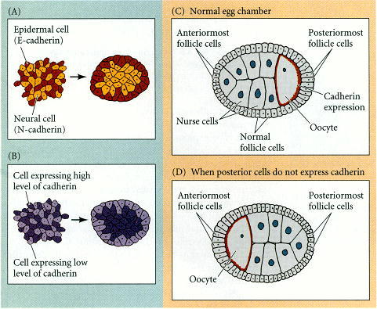

**Chemotactic induced Aggregation**

The crawling of biological cell is a complex phenomenon involving various biochemical and mechanical processes. Some of these processes are intrinsic to individual cells, while others pertain to cell-to-cell interactions and to their responses to extrinsically imposed cues. Here, we report an interesting aggregation dynamics of mathematical model cells, when they perform chemotaxis in response to an externally imposed global chemical gradient while they influence each other through a haptotaxis-mediated social interaction, which confers intriguing trail patterns. In the absence of the cell-to-cell interaction, the equilibrium population density profile fits well to that of a simple Keller-Segal population dynamic model, in which a chemotactic current density  competes with a normal diffusive current density , where p and ρ refer to the concentration of chemoattractant and population density, respectively. We find that the cell-to-cell interaction confers a far more compact aggregation resulting in a much higher peak equilibrium cell density. The mathematical model system is applicable to many biological systems such as swarming microglia and neutrophils or accumulating ants towards a localized food source.

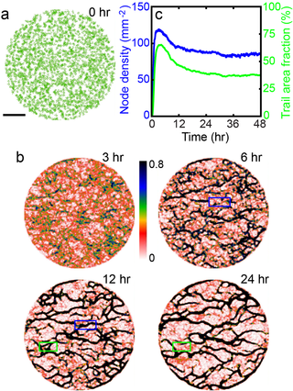

Understanding the mechanisms behind cell population dynamics is essential to a wide range of biological processes including development, wound healing, tumor expansion, and immune responses [[1](https://journals.plos.org/plosone/article?id=10.1371/journal.pone.0154717#pone.0154717.ref001)–[7](https://journals.plos.org/plosone/article?id=10.1371/journal.pone.0154717#pone.0154717.ref007)]. However, it is a very challenging task, since the relevant systems generally involve many different interacting constituents (cells) which are inherently nonlinear and the type of cell-to-cell interactions vary from one case to another. For example, neighboring cells can interact with each other by mechanical forces in a close-packed layer of cells [[8](https://journals.plos.org/plosone/article?id=10.1371/journal.pone.0154717#pone.0154717.ref008), [9](https://journals.plos.org/plosone/article?id=10.1371/journal.pone.0154717#pone.0154717.ref009)].

The local forces can then generate long-range spatio-temporal correlations. Some well-known examples include the ratchet-like tissue movement during dosal closure in the developing *Drosophila* embryo [[10](https://journals.plos.org/plosone/article?id=10.1371/journal.pone.0154717#pone.0154717.ref010)] and the waves and swirls in the *in vitro* systems of an expanding epithelial cell sheet [[2](https://journals.plos.org/plosone/article?id=10.1371/journal.pone.0154717#pone.0154717.ref002), [11](https://journals.plos.org/plosone/article?id=10.1371/journal.pone.0154717#pone.0154717.ref011), [12](https://journals.plos.org/plosone/article?id=10.1371/journal.pone.0154717#pone.0154717.ref012)]. Cells can also be coupled through diffusing chemical agents and matching receptors. One of the most well-studied examples of this type of cell is the traveling-wave chemotaxis of dictyostelium discodium (or dicty) amoebae [[13](https://journals.plos.org/plosone/article?id=10.1371/journal.pone.0154717#pone.0154717.ref013)–[15](https://journals.plos.org/plosone/article?id=10.1371/journal.pone.0154717#pone.0154717.ref015)]. Briefly, the starvation triggers amoebae to produce and excrete 3’,5’-cyclic adenosine monophosphate (cAMP) that diffuses to the neighboring cells which have cAMP receptors.

Not only can the cells amplify the level of cAMP, they can also dissociate cAMP to cGMP in a temporally coordinated manner. Consequently, the cAMP-mediated coupling can bring about large-scale cAMP waves. Therefore, for the case of dicty amoebae, the diffusive coupling and the cell-intrinsic nonlinear kinetics and adaptation are responsible for the collective phenomenon. The amoebae cells also actively move (i. e. chemotaxis) towards the higher concentration of cAMP while experiencing the positive slopes of cAMP waves.

In some cases, the chemical agents released by crawling cells do not diffuse but stay behind the cells, and become encapsuled into small vesicles (typical size, 40∼100 nm in diameter) called as exsosomes. Alternatively, they become bound to the two-dimensional substrate (or three-dimensional matrix) on which the cells are placed . In our recent work, we showed that in cultured microglia, the immune cells of the brain [[19](https://journals.plos.org/plosone/article?id=10.1371/journal.pone.0154717#pone.0154717.ref019)], a number of chemical markers (e.g. *α*5-integrin) are left behind the crawling traces of the cells and that these non-diffusing (but degrading) markers serve as intercellular signaling agents guiding their motility , enabling the cells to form intricate evolving network of trails

In short, microglia exhibit “haptotaxis” by following the trails they generate. Generally speaking, “haptotaxis” refers to the directed movement of cells controlled by the relative strengths of peripheral adhesions into some substrates.

Microglia also exhibit “chemotaxis” in response to the concentration gradient of adenosine monophosphate (ATP) [[22](https://journals.plos.org/plosone/article?id=10.1371/journal.pone.0154717#pone.0154717.ref022), [23](https://journals.plos.org/plosone/article?id=10.1371/journal.pone.0154717#pone.0154717.ref023)]. “Chemotaxis” is the directed movement of bacteria, eukaryotic cells, or multi-cellular organisms toward concentrations of environmental chemoattractants. Therefore, microglia movements can be driven by several different agents. Multi-modal communications are indeed very common for biological cells.

Neutrophils rely on integrins and lipid leukotriene B4 (LTB4) for swarming ; they also release exsosomes behind their moving trails as for intercellular signaling . Numerous chemokines are known to be involved in chemotaxing tumor cells and tumor cell migration is driven by haptotaxis as well as chemotaxis . Indeed, for many realistic biological settings, cell-to-cell interactions are mediated by several different modalities with many different intercellular signaling molecules working together. However, the potential interplay between these different modalities is largely unexplored.

Finally, we question the consequence of implementing the haptotactic cell-to-cell interaction for the cells that are already chemotaxing. The cells experience the same static p-gradient as shown in [Fig 3a](https://journals.plos.org/plosone/article?id=10.1371/journal.pone.0154717#pone-0154717-g003) (see [Fig 5a](https://journals.plos.org/plosone/article?id=10.1371/journal.pone.0154717#pone-0154717-g005), t = 0), but they now also have the q-mediated interaction forming trails. Due to the chemotactic force of the p-gradient, initially the self-organized trails exhibit some tendency to orient themselves towards the center (see [Fig 5a](https://journals.plos.org/plosone/article?id=10.1371/journal.pone.0154717#pone-0154717-g005), t = 6 hr, also see [S3 Movie](https://journals.plos.org/plosone/article?id=10.1371/journal.pone.0154717#pone.0154717.s006)).

On the other hand, the presence of the trail network can break the circular symmetry of the system and render the centroid of the “high density core area” not in the middle of, but off-center to, the peak of p. The core-centric chemotactic force competes with the non-centric haptotactic guide imposed by the trails. For the chosen set of parameter values and the p-landscape, we find that the high density core centroid is typically 32%∼35% off-centered while its azimuthal location changes with a different initial state of the cell population (see [S3a Fig](https://journals.plos.org/plosone/article?id=10.1371/journal.pone.0154717#pone.0154717.s003)). Importantly, however, the position of the (time-averaged) maximum cell density is still located at the peak of p (see [S3b Fig](https://journals.plos.org/plosone/article?id=10.1371/journal.pone.0154717#pone.0154717.s003)), which is also the global maximum of p + q

**Aggregation in sponges**

The biochemical and functional properties of p-glucuronidase and j?-galactosidase, isolated and partially purified from the sponge Geodia cydonium, were studied. The two glycosidases are not only localized in the cytoplasm but are also associated at a high activity with the cell membrane. The aggregation receptor, a low molecular weight cell surface-bound glycoprotein, is deglucuronylated by the action of the Geodia /3-glucuronidase both in the state at which the receptor is bound to the cell surface and in its isolated form. The deglucuronylated aggregation receptor can be reglucuronylated enzymatically by the extracellularly occurring homologous glucuronosyltransferase. Untreated cells lose their aggregation potency if they are incubated under conditions optimal for P-glucuronidase activity. Cells, depleted of membrane-bound pglucuronidase, do not show any reduction of their aggregation potency under identical conditions.

Cells that carry on their cell surface deglucuronylated molecules and are biologically characterized by only a low aggregation potency can be reglucuronylated in the presence of glucuronosyltransferase and UDP-glucuronic acid. These restored cells show again the original high aggregation potency. From the results presented it is assumed that cell aggregation can occur after glucuronylation of the aggregation receptor by the glucuronosyltransferase via a linkage of the aggregation factor with the aggregation receptor. Some evidence is presented, indicating that cell separation is the consequence of an activation of the cell membrane bound P-glucuronidase, which results in a deglucuronylation of the aggregation receptor.

Among the different biological models studied to understand cell-cell aggregation processes both on the cellular and biochemical level, the retina system (for a survey, see Refs. 1 and 2) and the sponge cell system (for a survey, see Ref. 3) are the most widely used. It is owing to Moscona (4), who succeeded to isolate an “extracellularly functioning material” from the sponge Microciona prolifera which promotes reag- * This work has partially been supported by the Academy of Science and Letters, Maim, Germany and by the Bundesministerium fiir Forschung und Technologie.

Aggregation of single cells. This “material” was later termed aggregation factor; in 1973 the factor was purified and characterized from the sponge Geodia cydonium (5, 6). The aggregation factor of Geodia is associated with high molecular weight particles with a sedimentation coefficient (s&J of 90 (6a); in the presence of minute amounts of Ca”, the particles form complexes which have a sedimentation coefficient of 3,000 (6). The Geodia particles occur in the intercellular space and are found to act multifunctionally. The first subunit identified was the aggregation factor (5, 7); later a series of glycosyltransferases was identified as subunits of the Geodia particles: sialyltransferase (8), glucuronosyltransferase (9), and galactosyltransferase (9).

Hence, the Geodia particles represent a multiglycosyltransferase system associated with an aggregation promoting activity. The Geodia particles, in particular the aggregation factor associated with them, bind to specific cell surface molecules, the so-called aggregation receptors, which are of low molecular weight (Mr = approximately 20,000; s$J,~ = 2.6) and consist chemically of glycoproteins (10). The termini of the aggregation receptor which are involved in the binding with the aggregation factor were determined to consist of glucuronic acid (11).

A further cell membrane component, the antiaggregation receptor (Mr = 180,000), a glycoprotein with D-galactose termini (12), modulates the activity of the aggregation factor; the antiaggregation receptor is most likely involved in a controlled segregation and subsequent reaggregation of the cells in randomly aggregated cell clumps. Stimulated by the study of Aoyagi et al. (13), demonstrating the presence of a variety of glycosidases on the surface of mammalian cells, we searched for the cell surface enzymes neuraminidase, ,&glucuronidase, and ,&galactosidase.

Only the latter two enzymes could be detected, partially purified, and characterized. In addition, attempts were made to determine the role of both the ,&galactosidase and the P-glucuronidase in the control of the reaggregation process, with the main emphasis on the latter enzyme. From our studies, we hypothesized that the ,&glucuronidase and the glucuronosyltransferase might control the initial events of cell aggregation, mediated by the aggregation factor and the aggregation receptor, while the ,&galactosidase and the galactosyltransferase might play a role in the secondary event the “sorting out.”

# **Experimental analyses in the early development of Echinoderms, Amphibians and birds.**

Gastrulation does not always proceed exactly as described above. In the course of evolution, certain [animal](https://www.britannica.com/animal/animal) groups have modified this critical stage of embryonic [development](https://www.britannica.com/science/biological-development), and these modifications have undoubtedly contributed to the successful continuation of species. In the primitive fishlike chordate [amphioxus](https://www.britannica.com/animal/amphioxus), for example, the invaginating blastoderm eventually comes into close contact with the inner surface of the [ectoderm](https://www.britannica.com/science/ectoderm), thus practically squeezing the blastocoel out of existence or at least reducing it to a narrow crevice between the ectoderm and the endomesoderm.

In [echinoderms](https://www.britannica.com/animal/echinoderm), on the other hand, a smaller portion of the blastoderm invaginates, and the blastocoel remains as a spacious internal cavity between the ectoderm and the endomesoderm. It persists as the primary body cavity and is the only body cavity (apart from the cavity of the alimentary canal) in such invertebrates as nematodes and rotifers.

In the double-walled-cup stage, the two internal germinal layers—endoderm and mesoderm—may not yet be distinct. Their separation may occur later, in the second phase of gastrulation, by one of two methods. One is the development of outpocketings from the wall of the archenteron. In [starfishes](https://www.britannica.com/animal/sea-star) and other echinoderms, the deep part of the endomesodermal invagination forms two thin-walled sacs, one on each side of the gastrula. These are the rudiments of the mesoderm; the remaining part of the archenteron becomes the [endoderm](https://www.britannica.com/science/endoderm) and produces the lining of the gut.

The cavities within the mesodermal sacs expand to become the [coelom](https://www.britannica.com/science/coelom), the secondary body cavity of the animal. A somewhat similar process of [mesoderm](https://www.britannica.com/science/mesoderm) and coelom development occurs in amphioxus among the chordates, except that a series of mesodermal sacs forms on either side of the [embryo](https://www.britannica.com/science/embryo-human-and-animal), foreshadowing the segmented (metameric) structure common to chordates. Only the most anterior pairs of the mesodermal sacs actually contain a cavity at the time of their formation; the more posterior ones are solid masses of cells separating from the archenteric wall and from one another and developing coelomic cavities later.

A second method of mesoderm formation is by the splitting off of mesodermal cells from the original common mass of endomesoderm. This may take the form of single cells detaching themselves from the archenteron or of whole sheets of cells splitting off from the endoderm. An example of the latter type is seen in the gastrulation of [amphibians](https://www.britannica.com/animal/amphibian). The development of specific regions of the early amphibian embryo—by the use of natural pigmentation or artificially introduced dyes—can be followed and their location in the [adult](https://www.britannica.com/science/adulthood) recorded in diagrams called fate maps.

The fate map of a [frog](https://www.britannica.com/animal/frog) [blastula](https://www.britannica.com/science/blastula) just prior to gastrulation demonstrates that the materials for the various organs of the embryo are not yet in the position corresponding to that in which the organs will lie in a fully developed animal. The endodermal material for the foregut, for example, lies not far from the vegetal pole; the ectodermal component of the mouth region (stomodeum) is situated close to the animal pole. Extensive rearrangement of the embryo is necessary to bring all the parts into their correct relationships.

Because of the large amount of yolk and resulting uneven [cleavage](https://www.britannica.com/science/cleavage-embryo), gastrulation in amphibians cannot proceed by a simple infolding of the vegetal hemisphere. A certain amount of invagination does take place, assisted by an active spreading of the animal hemisphere of the embryo; as a result, the ectoderm covers the endodermal and mesodermal areas. The spreading is sometimes described as an “overgrowth”—an inappropriate term, since no growth or increase of mass is involved. The future ectoderm simply thins out, expands, and covers a greater surface of the embryo in a movement known as epiboly.

Gastrulation in amphibians, in [lungfishes](https://www.britannica.com/animal/lungfish), and in the [cyclostomes](https://www.britannica.com/animal/cyclostome) (hagfishes and lampreys) begins with the formation of a pit on what will become the back (dorsal) side of the embryo. The pit represents the active shifting inward of the cells of the blastoderm. As these cells undergo a change in shape, there occurs also a contraction at the external surface, with [adjacent](https://www.merriam-webster.com/dictionary/adjacent) cells being drawn toward the centre of the contraction even before an actual depression is formed. The cells most concerned in this process will become part of the future foregut.

Further movement of the cells inward results in the formation of a distinct pit, which rapidly develops into a pocket-like archenteron with its opening, the [blastopore](https://www.britannica.com/science/blastopore). Once the archenteron is formed, more and more of the exterior cells roll over the edge of the blastopore and disappear into the interior. In the course of gastrulation the shape of the blastopore changes from a simple pit to a transverse slit and finally into a groove encircling the yolky material at the vegetal pole. As a result of epiboly of the animal hemisphere, the upper edge of the groove is gradually pushed down until the yolky cells of the vegetal pole are covered completely.

The edges of the blastopore then converge toward the vegetal pole, the slit between them being eventually reduced to a narrow canal, which lies at the posterior end of the embryo and, in some species, becomes the anal opening. (In other cases the canal closes, and a new anal opening breaks through nearby, slightly more ventrally.)

The cavity of the archenteron increases as more material from the outside is transferred inward, and the blastocoel becomes almost completely obliterated. Both mesoderm and endoderm are shifted into the interior, and only the ectoderm remains on the embryo surface. The mesoderm splits from the endoderm: the endoderm lines the archenteric cavity (and eventually becomes the lining of the alimentary canal), as the mesoderm surrounds the endoderm to form the chordamesodermal mantle. By the time the blastopore closes, the three germ layers are in their correct spatial relationship to each other.

# **Early Development in Birds**

## Cleavage in Bird Eggs

Ever since Aristotle first followed its 3-week development, the domestic chicken has been a favorite organism for embryological studies. It is accessible all year and is easily raised. Moreover, at any particular temperature, its developmental stage can be accurately predicted. Thus, large numbers of embryos can be obtained at the same stage. The chick embryo can be surgically manipulated and, since it forms most of its organs in ways very similarly to those of mammals, it has often served as a surrogate for human embryos.

Fertilization of the chick egg occurs in the oviduct, before the albumen and the shell are secreted upon it. The egg is telolecithal (like that of the fish), with a small disc of cytoplasm sitting atop a large yolk. Like fish eggs, the yolky eggs of birds undergo discoidal meroblastic cleavage. Cleavage occurs only in the blastodisc, a small disc of cytoplasm 2–3 mm in diameter at the animal pole of the egg cell. The first cleavage furrow appears centrally in the blastodisc, and other cleavages follow to create a single-layered blastoderm.

As in the fish embryo, these cleavages do not extend into the yolky cytoplasm, so the early-cleavage cells are continuous with each other and with the yolk at their bases. Thereafter, equatorial and vertical cleavages divide the blastoderm into a tissue five to six cell layers thick. These cells become linked together by tight junctions.Between the blastoderm and the yolk is a space called the **subgerminal cavity** This space is created when the blastoderm cells absorb fluid from the albumin (“egg white”) and secrete it between themselves and the yolk. At this stage, the deep cells in the center of the blastoderm are shed and die, leaving behind a one-cell-thick **area pellucida**. This part of the blastoderm forms most of the actual embryo. The peripheral ring of blastoderm cells that have not shed their deep cells constitutes the **area opaca**. Between the area pellucida and the area opaca is a thin layer of cells called the **marginal zone** (or **marginal belt**) Some of the marginal zone cells become very important in determining cell fate during early chick development.

